DILSHAD

231501041

EXPERIMENT 5

Aim:
To demonstrate the difference between the HTTP GET and POST methods using a Java Servlet, where a form will be created and requests will be handled accordingly by the GET and POST methods.
CODE:
HTML :
<!DOCTYPE html>
<html lang="en">
<head>
<meta charset="UTF-8">
<meta name="viewport" content="width=device-width, initial-scale=1.0">
<title>GET vs POST Example</title>
<style>
body {
font-family: Arial, sans-serif; background-color: #f4f4f9; color: #333;

margin: 0;
padding: 0;
}

h2 {
color: #4CAF50; text-align: center; margin-top: 50px;
}

.container { width: 50%;
margin: 0 auto; background-color: #fff; padding: 30px;
border-radius: 8px;
box-shadow: 0 4px 8px rgba(0, 0, 0, 0.1);
}

.form-group {
margin-bottom: 20px;
}

label {
font-size: 16px; color: #555;
}

input[type="text"] { width: 100%;

padding: 10px; margin-top: 5px; border-radius: 4px;
border: 1px solid #ccc; box-sizing: border-box;
}

button {
background-color: #4CAF50; color: white;
padding: 10px 20px; border: none;
border-radius: 4px; cursor: pointer; font-size: 16px;
}

button:hover {
background-color: #45a049;
}

.form-container { margin-bottom: 30px;
}

hr {
border: 1px solid #ddd;
}

.result {

background-color: #f9f9f9; border-left: 4px solid #4CAF50; padding: 20px;
margin-top: 20px; font-size: 16px; border-radius: 4px;
}
</style>
</head>
<body>
<div class="container">
<h2>GET vs POST Request Demonstration</h2>

<!-- Form to demonstrate GET method -->
<div class="form-container">
<h3>GET Method</h3>
<form action="DemoServlet" method="GET">
<div class="form-group">
<label for="data">Enter Data (GET):</label>
<input type="text" name="data" required>
</div>
<button type="submit">Submit (GET)</button>
</form>
</div>

<hr>

<!-- Form to demonstrate POST method -->
<div class="form-container">
<h3>POST Method</h3>

<form action="DemoServlet" method="POST">
<div class="form-group">
<label for="data">Enter Data (POST):</label>
<input type="text" name="data" required>
</div>
<button type="submit">Submit (POST)</button>
</form>
</div>

<!-- Result section will be dynamically updated -->
<div class="result" id="result">
<!-- Display GET or POST request result here -->
</div>
</div>
</body>
</html>

Servlet.java:
import java.io.*; import javax.servlet.*;
import javax.servlet.http.*;
public class DemoServlet extends HttpServlet {
// Handle GET request @Override
protected void doGet(HttpServletRequest request, HttpServletResponse response) throws ServletException, IOException {
// Set response content type response.setContentType("text/html"); PrintWriter out = response.getWriter(); String data = request.getParameter("data");

out.println("<html><body>");

out.println("<h2>GET Request Received</h2>");

if (data != null && !data.isEmpty()) {
out.println("<p>Data received via GET method: " + data + "</p>");
} else {
out.println("<p>No data received in GET request.</p>");
}

out.println("</body></html>");
}

// Handle POST request @Override
protected void doPost(HttpServletRequest request, HttpServletResponse response) throws ServletException, IOException {
// Set response content type response.setContentType("text/html"); PrintWriter out = response.getWriter(); String data = request.getParameter("data"); out.println("<html><body>");
out.println("<h2>POST Request Received</h2>");

if (data != null && !data.isEmpty()) {
out.println("<p>Data received via POST method: " + data + "</p>");
} else {
out.println("<p>No data received in POST request.</p>");
}

out.println("</body></html>");
}
}

web.xml :
<web-app xmlns="http://java.sun.com/xml/ns/javaee" xmlns:xsi="http://www.w3.org/2001/XMLSchema-instance" xsi:schemaLocation="http://java.sun.com/xml/ns/javaee
http://java.sun.com/xml/ns/javaee/web-app_3_1.xsd" version="3.1">

<servlet>
<servlet-name>DemoServlet</servlet-name>
<servlet-class>DemoServlet</servlet-class>
</servlet>

<servlet-mapping>
<servlet-name>DemoServlet</servlet-name>
<url-pattern>/DemoServlet</url-pattern>
</servlet-mapping>

</web-app>

OUTPUT :
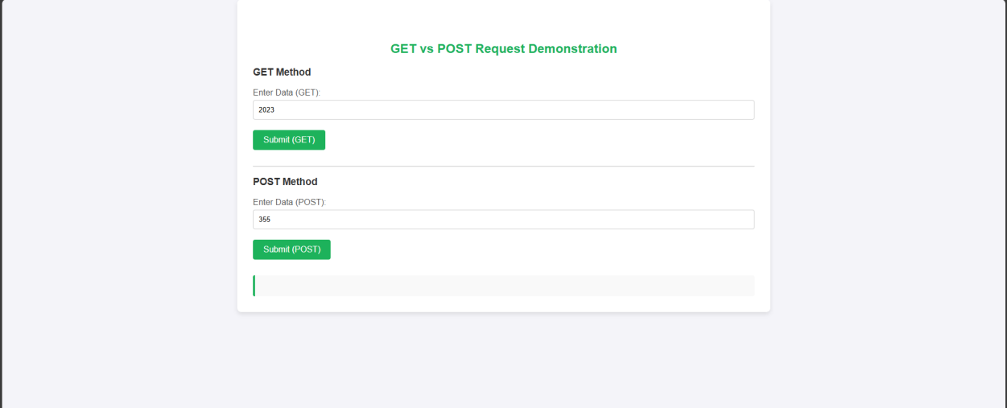

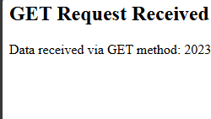



RESULT :
Thus the give program is executed successfully.

